Homework 2
February 16, 2026
Peyton Miller

Download the script “HW2_a” from Blackboard in either MATLAB or Python, as well as
the zip file “HW2_data.” In this problem, you will assess the efficiency and applicability of
the five main factorization/decompositions we have discussed: LU, QR, Cholesky, Eigen
decomposition, and the SVD. Each datafile contains a matrix, 𝐴, which varies in size. We
will focus on solving 𝐴𝑥 =𝑏.
(i) For each dataset (1-7), first determine the properties of A (size, symmetric, positive definite). The code will help you do this. Document this in your homework response.
Data Set | Size | Symmetric | Positive Definite | Failed Method
1 | 10 x 10 | No | No | Cholesky
2 | 100 x 100 | No | No | Cholesky
3 | 1000 x 1000 | No | No | Cholesky
4 | 1000 x 1000 | Yes | No | Cholesky
5 | 1000 x 1000 | Yes | Yes
6 | 500 x 20 | No | No | Cholesky, Eigen
7 | 5000 x 1000 | No | No | LU, Cholesky, Eigen

(ii) Based on what you find in (i), what decompositions will you be able to apply to each dataset? Change the variable “methods” in the code to reflect this for each dataset.
QR decomposition and SVD.
(iii) Use the code to solve the linear system, starting with 𝒙=𝟏, i.e. the ones vector. Provide details on the error in finding 𝒙, the residual 𝑨𝒙−𝒃, and the time it takes to compute (all provided by the code). Comment on the general behavior of certain algorithms and which might be more effective.
Used AI to help me figure out how to change the x vector into x = 1 (x_true = np.ones(n,2) → x_true = np.ones((n,1))
DATA SET 1
- The most effective method will be LU decomp. It has the lowest error and residual and it completes the code in the shortest amount of time. The least effective, aside from Cholesky, is Eigen decomp. The error and residual is high as well as the run time (least accurate).
Method | Error | Residual | Time
LU | 5.98e-16 | 1.02E-15 | 0.000s
QR | 1.57e-15 | 4.19e-15 | 0.000s
Cholesky | FAILED NOT SPD
Eigen | 8.35e-15 | 1.77e-14 | 0.002s
SVD | 1.93e-15 | 6.74e-15 | 0.000s

DATA SET 2
- The most effective method for this data set will be LU because it has the lower error. However, QR is close in effectiveness due to it having the lowest residual. SVD is a nice in between with a relatively low error and residual. Eigen is still the least effective aside from Cholesky.
Method | Error | Residual | Time
LU | 6.18e-14 | 1.10e-13 | 0.001s
QR | 3.63e-14 | 5.96e-14 | 0.001s
Cholesky | FAILED NOT SPD
Eigen | 3.08e-13 | 7.34e-13 | 0.005s
SVD | 4.99e-14 | 2.07e-13 | 0.001s

DATA SET 3
- The most effective is the QR decomp. The error and the residual is lowest. The eigen decomp is still the least effective.
Method | Error | Residual | Time
LU | 6.37e-11 | 1.62e-11 | 0.008s
QR | 2.23e-11 | 2.51e-12 | 0.023s
Cholesky | FAILED NOT SPD
Eigen | 6.10e-9 | 2.81e-10 | 0.345s
SVD | 9.71e-11 | 4.84e-12 | 0.070s

DATA SET 4
- The most effective will be the QR decomp however the Eigen decomp is very close. The reason the Eigen decomp is effective for this set and not the others is because the set is symmetric. The least effective is LU decomp however is does run the fastest.
Method | Error | Residual | Time
LU | 7.37e-12 | 4.27e-10 | 0.008s
QR | 4.31e-12 | 7.41e-11 | 0.024s
Cholesky | FAILED NOT SPD
Eigen | 4.00e-12 | 1.38e-10 | 0.061s
SVD | 7.06e-12 | 1.43e-10 | 0.074s

DATA SET 5
- The most effective method will be the Cholesky decomp because it is SPD. The least effective is the Eigen decomp. Cholesky decomp algorithm is also the fastest.
Method | Error | Residual | Time
LU | 9.37e-9 | 3.49e-11 | 0.008s
QR | 2.72e-8 | 8.81e-11 | 0.023s
Cholesky | 3.74e-9 | 3.65e-11 | 0.005s
Eigen | 2.03e-3 | 1.75e-10 | 0.056s
SVD | 7.53e-8 | 1.85e-10 | 0.069s

DATA SET 6
- The most effective is the QR however QR and LU are close is effectiveness. Do to the dimensions of this matrix, Eigen failed. SVD is the least effective however runs the fastest.
Method | Error | Residual | Time
LU | 1.36e-15 | 3.48e-14 | 0.001s
QR | 1.32e-15 | 3.35e-14 | 0.000s
Cholesky | FAILED NOT SPD
Eigen | FAILED NOT SQUARE
SVD | 1.45e-14 | 2.98e-13 | 0.000s

DATA SET 7
- The most effective is the QR decomp versus the SVD. The SVD has a higher error, residue, and time. The LU, Eigen, and Cholesky will all fail due the properties.
Method | Error | Residual | Time
LU | FAILED OVERDETERMINED
QR | 8.55e-14 | 5.49e-12 | 0.147s
Cholesky | FAILED NOT SPD
Eigen | FAILED NOT SQUARE
SVD | 1.94e-13 | 1.32e-11 | 0.206s

After comparing the 7 data sets we can fine that overall, QR decomposition is the most effective. When it comes to SPD matrix, Cholesky will do the best. Eigen decomposition is the least effective since eigen only works best with the matrix is symmetric and square (not realistic conditions for every matrix).
(iv) Now, make 𝒙 an nx5 vector (can be random numbers or the 1’s vector). How does the performance of the algorithms change? Focus on datasets 5, 6, and 7.

Output:

Matrix is 10 x 10
A is NOT SPD.
shapes: (10, 10) (10, 10) (10, 10) (10, 5)
LU | error: 1.53e-15 | residual: 3.05e-15 | time: 0.000s
QR | error: 3.56e-15 | residual: 9.20e-15 | time: 0.000s
Cholesky | FAILED (Matrix is not positive definite)
Eigen | error: 1.90e-14 | residual: 3.91e-14 | time: 0.000s
SVD | error: 4.18e-15 | residual: 1.42e-14 | time: 0.000s

Matrix is 100 x 100
A is NOT SPD.
shapes: (100, 100) (100, 100) (100, 100) (100, 5)
LU | error: 5.82e-13 | residual: 4.22e-13 | time: 0.000s
QR | error: 1.63e-13 | residual: 1.66e-13 | time: 0.000s
Cholesky | FAILED (Matrix is not positive definite)
Eigen | error: 6.87e-13 | residual: 2.02e-12 | time: 0.004s
SVD | error: 1.54e-13 | residual: 4.57e-13 | time: 0.001s

Matrix is 1000 x 1000
A is NOT SPD.
shapes: (1000, 1000) (1000, 1000) (1000, 1000) (1000, 5)
LU | error: 9.70e-10 | residual: 7.25e-11 | time: 0.008s
QR | error: 9.53e-11 | residual: 6.30e-12 | time: 0.023s
Cholesky | FAILED (Matrix is not positive definite)
Eigen | error: 1.28e-08 | residual: 6.12e-10 | time: 0.342s
SVD | error: 1.71e-10 | residual: 1.12e-11 | time: 0.069s

Matrix is 1000 x 1000
A is symmetric.
A is NOT positive definite.
shapes: (1000, 1000) (1000, 1000) (1000, 1000) (1000, 5)
LU | error: 4.50e-11 | residual: 2.07e-09 | time: 0.008s
QR | error: 9.82e-12 | residual: 1.92e-10 | time: 0.023s
Cholesky | FAILED (Matrix is not positive definite)
Eigen | error: 4.33e-12 | residual: 3.22e-10 | time: 0.055s
SVD | error: 1.64e-11 | residual: 3.30e-10 | time: 0.071s

Matrix is 1000 x 1000
A is symmetric.
A is SPD!
shapes: (1000, 1000) (1000, 1000) (1000, 1000) (1000, 5)
LU | error: 1.58e-08 | residual: 1.44e-10 | time: 0.008s
QR | error: 1.32e-07 | residual: 2.21e-10 | time: 0.025s
Cholesky | error: 4.73e-09 | residual: 1.34e-10 | time: 0.006s
Eigen | error: 2.32e-08 | residual: 4.21e-10 | time: 0.057s
SVD | error: 1.68e-07 | residual: 4.34e-10 | time: 0.068s

Matrix is 500 x 20
A is NOT SPD.
shapes: (500, 500) (500, 20) (20, 20) (500, 5)
LU | error: 2.70e-15 | residual: 7.61e-14 | time: 0.001s
QR | error: 7.20e-15 | residual: 1.61e-13 | time: 0.000s
Cholesky | FAILED (Cholesky requires a square matrix.)
Eigen | FAILED (Eigen decomposition requires a square matrix.)
SVD | error: 3.18e-14 | residual: 6.62e-13 | time: 0.000s

Matrix is 5000 x 1000
A is NOT SPD.
shapes: (5000, 5000) (5000, 1000) (1000, 1000) (5000, 5)
LU | FAILED (Incompatible/overdetermined system at row 1000: residual [-3.24007488e-12 -3.24007488e-12 -3.24007488e-12 -3.24007488e-12
-3.24007488e-12])
QR | error: 2.16e-13 | residual: 1.48e-11 | time: 0.149s
Cholesky | FAILED (Cholesky requires a square matrix.)
Eigen | FAILED (Eigen decomposition requires a square matrix.)
SVD | error: 4.45e-13 | residual: 3.06e-11 | time: 0.207s

When the matrix x becomes a n x 5 matrix, the run time is significantly less, however the error is higher for most decompositions.

We will now revisit image analyzing using the SVD. Download the folder “mnist_4” from Blackboard, which contains 12 images of a handwritten digit “4”. Each image is 28x28. Use the Blackboard code “HW2_b” for your analysis.
Copied question into ChatGPT for assistant. Needed help understanding how to answer/how to code answer and how to create plots. All plots are from ChatGPT.
(i)Load each image into MATLAB or Python. This image we can treat as a 28x28 matrix 𝐴. Compute the SVD of each image. Plot the singular values (remember that they are on the diagonal), and comment on whether the singular values quickly or slowly decay.
(ii) Recall again that the SVD can be rewritten as 𝑨=𝑼𝚺𝑽⊤ ⇒𝑨=∑𝒖𝑖𝝈𝑖𝒗𝒊⊤𝑛𝑖=1 where here 𝑛=28. Using the MATLAB or Python script provided, investigate how many terms in the sum are necessary to reconstruct each digit. Comment on whether there is some “global minimum” number of singular values needed. Provide plots that illustrate how the digits are reconstructed well for only 𝑘 <𝑛 components
Orginal Picture | Plot and Comments
 | 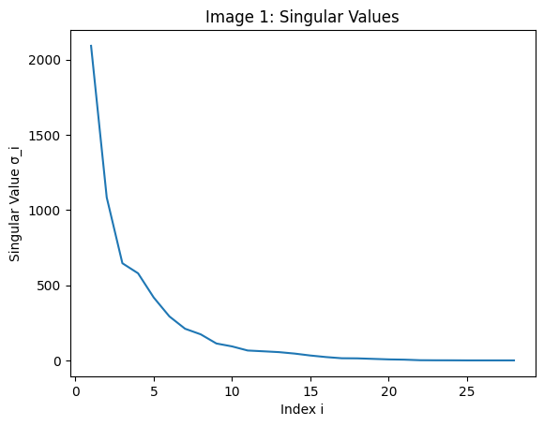
 | 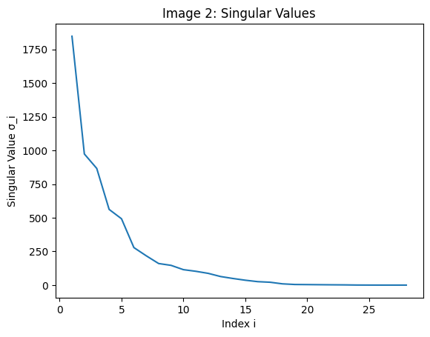
 | 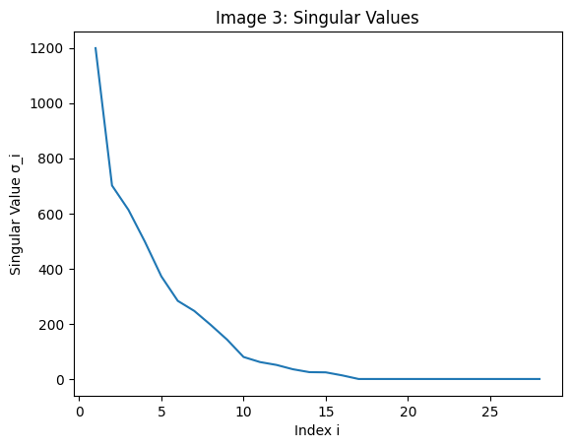
 | 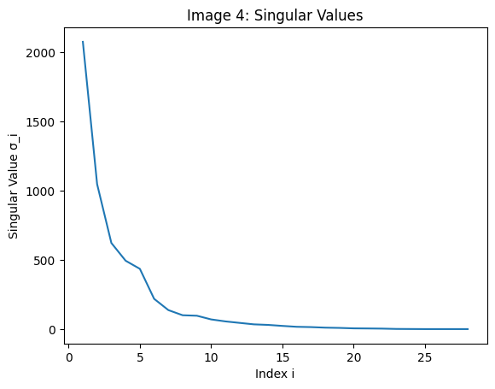
 | 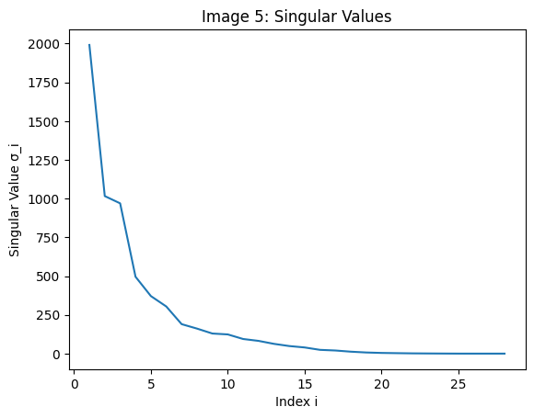
 | 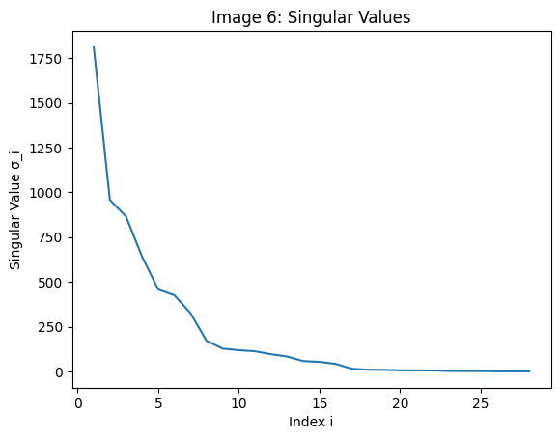
 | 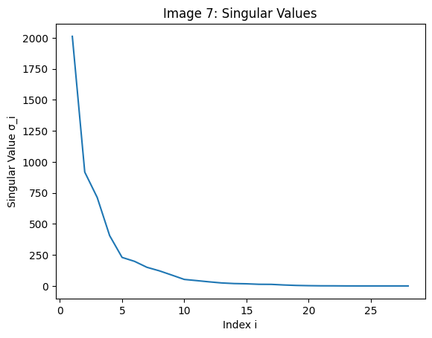
 | 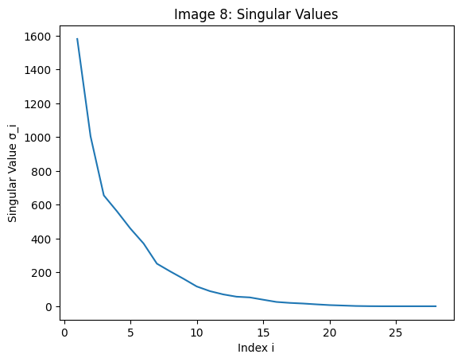
 | 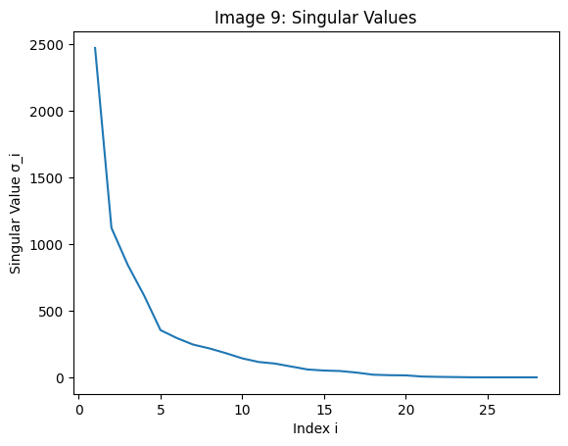
 | 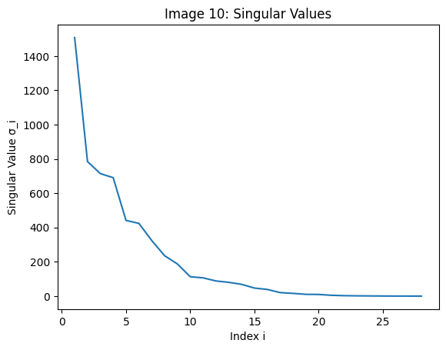
 | 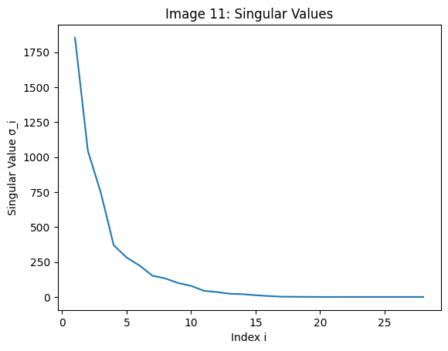
 | 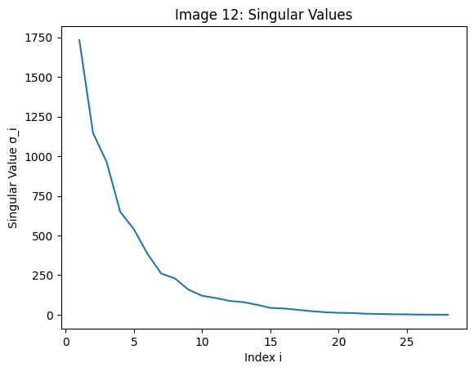

With each graph you can see a quick decay with the singular values. Each plot also shows the zeroing off point at around 15-17. Thus there need to be at least 15 terms in the sum for a reconstruction. According the the AI bot, there is no strict global minimum. This is because k varies in every image.

Download the script “HW2_c”, which loads the same digit images but now stores them as a 28^2 =784 dimensional vector, and then constructs a matrix, 𝑋 with each image along the columns. Consider the matrix 𝐴=𝑋 𝑋′ which is the outer product of the two matrices. This should be 784x784. We will revisit this later as the sample covariance of our data. The following operations can then be performed on 𝐴:
Taking the average over the second dimension of 𝐴 provides an “average” dataset. If we cast this average back into a 28x28 matrix, we should get the average image, 𝑿̅.
We can center the data in 𝑨 so that the mean is zero by subtracting, i.e. 𝑨∗ =𝑨−𝑿̅.
This matrix is now symmetric positive definite. This means that the SVD of this image, 𝑨∗ =𝑼𝚺𝑽⊤, contains similar information to the eigen decomposition of the original matrix 𝑿.
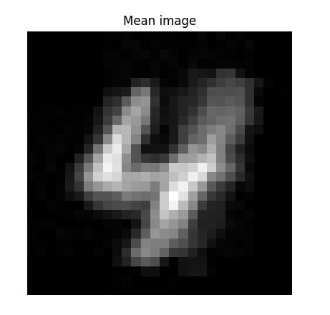
- Use the code to visualize the “mean” image. What do you see?
The mean image represents all the pixels of each 28x28 picture being “averaged” together. This creates a blurred picture of a 4. You can see the outer dark gray edges is when the least number of different pixels sat and the white portion is where they overlapped.

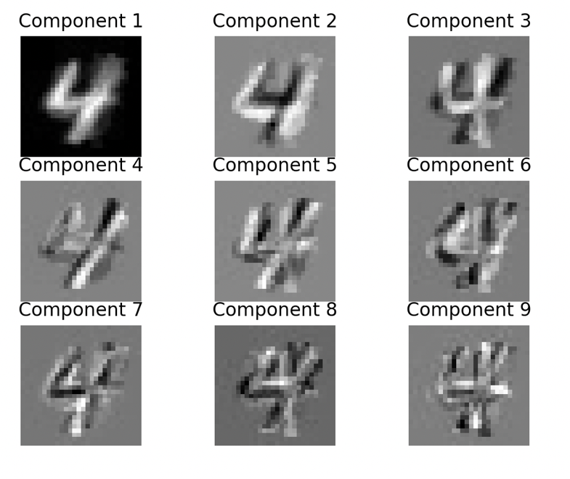
- Visualize the components of 𝑼. What do you see?
(Asked ChatGPT to explain the components in a lot of detail)
Each component represents a direction in pixel space which the digits vary the most. Component 1 is the direction of the maximum variance a.k.a the “main direction.” Each component after captures a slight difference in the picture, 3 is slated difference, etc.

